VIT
VELLORE INSTITUTE OF TECHNOLOGY
CHENNAI
FALL SEMESTER 2026–2027
BACSE202 – DATABASE MANAGEMENT SYSTEMS
DIGITAL ASSIGNMENT
WILDGUARD
AI-POWERED WILDLIFE TRACKING SYSTEM
Academic detail | Information
Faculty | Dr. S. Geetha
Slot | D1 + TD1
Class | CH2026270101707
Date | 02.11. 2026
GitHub repository | https://github.com/MridulaArun/WildGuard---AI-Powered-Animal-Tracking-System
YouTube demo | https://youtu.be/x1fXEyM7alA?si=o3o3N5kMqOq_6tMi

TEAM MEMBERS
S. No. | Name | Register Number
1 | Mridula Arun Kumar | ___________25BCE5804_____________
2 | Divya Keerthana S | ___________25BCE5741
3 | Kavya Sri K | ___________25BCE5346

Department of Computer Science and Engineering

ABSTRACT

WildGuard is a wildlife monitoring system that analyses complex reserve environments using an underlying database. Animals will often be found moving through high-risk areas within large natural reserves such as roads, farmland and human settlements. Analyzing large amounts of spatial data and risk events can become tricky to be manually done. WildGuard provides an efficient solution to this using a powerful spatial relational database with an AI prediction tool.

The database has been designed using PostgreSQL and PostGIS. To ensure integrity Primary Keys, Foreign Keys, CHECK, UNIQUE and default values have been used. The main aspects of the database include Species, Animal, Reserve, GPS Tracking, Device, Health, Habitat Area, Risk Area, Prediction, Alert, Ranger and Alert Assignment, and an Audit Log. The database also includes a lot of spatial elements. For example, the Animal table has a POINT data type to store accurate locations of animals. The Reserve, Habitat Area and Risk Area tables have POLYGON data types. There are also a lot of spatial functions within the database such as ST_Within to check if animals are within a habitat/risk area.

The database has a lot of optimizations. Indexes have been used along with PL/pgSQL functions, Triggers and Views to validate data, check if animals are near any risk areas, create alerts automatically, assign tasks to people and maintain audit trails.

The wildlife system has been implemented as a complete pipeline. SQL queries are continuously running to format the raw telemetry data stored in the PostgreSQL/PostGIS database. The Neo4j database will then use this data to create interactive dashboards. The AI Prediction part of the system will look at the patterns of how animals are moving and create risk levels and risk scores. Alerts will be created automatically based on previous confirmed events or predictions using machine learning to ensure rangers are sent out to help prevent any risk to the ecology and humans.

Keywords: Wildlife Monitoring, PostgreSQL, PostGIS, Spatial Database, GPS Tracking, Risk Area Detection, Database Normalisation, Triggers, Alerts, Ranger Assignment, AI Prediction.

REPORT CONTENTS
1. Introduction
2. Problem Statement, Objectives and Scope
3. Existing Systems
4. Requirements and Proposed Architecture
5. ER Diagram and Relational Schema
6. Keys, Constraints and Functional Dependencies
7. Normalization
8. Implementation Details
9. SQL Operations and Implemented Features
10. Testing, Results and Discussion
11. Limitations and Future Enhancements
12. Conclusion
References
Appendix – Submission and Screenshot Checklist

INTRODUCTION

Wildlife conservation involves monitoring animal populations, understanding movement patterns and responding to threats around protected areas. GPS collars and field devices can generate location observations at regular intervals. These observations become more useful when connected to reliable information about species, individual animals, reserves, habitats, risk zones and conservation staff.

WildGuard is designed as a central information system for this purpose. It helps log the tracking of the health and location of endangered animals present in a reserve with the help of a collar. The animals usually reside in their given habitat zones in the reserve, however when left to roam free, there is a chance that they might enter zones where they may encounter risk events like poaching, human settlements, environmental factors etc. In order to mitigate these risks, rangers are assigned to the specific risk events. The assignment and actions of the rangers are recorded in the audit log.

Using the recorded data logs, we have built a ai prediction layer that will enable the system itself to assess the level of risks presented by the various risk events, whether they present enough of a risk for a ranger to attend to it, and also how to mitigate the risk.

On the technical level, PostgreSQL provides the relational foundation, while PostGIS adds spatial data types and functions so that animal positions can be evaluated against geographic boundaries. Risk events and alerts provide a structured path from raw observations to ranger response. We have also developed a frontend dashboard in order to view the system functionalities.

2. PROBLEM STATEMENT, OBJECTIVES AND SCOPE

2.1 Problem statement
Wildlife may move near roads, human settlements, agricultural land and poaching-risk areas. Manually tracking GPS and incident data at scale is challenging. Rangers need a unified view of animals, locations, risk events, alerts and predictions. Without a structured database and spatial analysis, it is difficult to connect a location observation to the relevant reserve or risk zone and maintain a traceable response workflow.

2.2 Objectives
- Maintain structured records of species and individual animals.
- Record GPS observations with timestamps, locations and movement speed.
- Store reserve boundaries, habitat zones and risk-zone boundaries as spatial data.
- Identify GPS observations that fall within or near defined risk zones.
- Record risk events with the animal, zone and tracking observation that led to detection.
- Store prediction category, probability, timestamp and review status.
- Generate alerts from detected events or predictions and support ranger assignment.
- Maintain device and animal health information.
- Provide SQL queries and views for reporting and dashboard summaries.
- Apply DBMS principles to preserve consistency and support efficient retrieval.

2.3 Scope
The database scope includes animal and species management, reserve and habitat management, GPS tracking, device records, health records, spatial risk zones, risk events, prediction storage, alert management, ranger information and alert assignments. The SQL script also contains functions and views for animal status, reserve summaries, device health, risk scores, latest positions and ranger workload.
The system supports conservation monitoring and decision-making; it does not replace field verification, veterinary judgement or ranger assessment. Output quality depends on GPS/device data, spatial boundary accuracy and the validity of any external prediction model.

3. EXISTING SYSTEMS AND COMPARATIVE STUDY

System | Purpose and capabilities | Relevance to WildGuard
EarthRanger | Conservation operations platform combining field observations, GPS collar data, personnel and other technology in a shared operational view; supports movement monitoring and alerts [1]. | Shows the value of a unified map and alert workflow.
Movebank | Online animal movement and sensor-data platform for managing, sharing, analysing and archiving tracking data [2]. | Reference for long-term management of animal locations and sensor observations.
SMART Conservation Tools | Management tool to help protected-area and wildlife managers monitor and manage patrol activities [3]. | Highlights ranger operations and structured field information.

3.1 Observations
- EarthRanger demonstrates the operational value of combining wildlife, staff and event information.
- Movebank focuses on animal movement observations and associated sensor data.
- SMART focuses on patrol activity and protected-area management.
WildGuard seeks to build on these pre-existing systems and tools, providing a unified environment with multiple views for all kinds of users. By logging the animal’s health and location data, we can build on the patterns established and develop an AI prediction model which will help in the risk assessment and management by rangers. It also allows external organizations concerned with the management of the endangered populations of the species present in these reserves.

4. REQUIREMENTS AND PROPOSED SYSTEM ARCHITECTURE

4.1 Functional requirements
- Create and maintain species and animal records, including conservation status, tag identifier and animal health status.
- Associate each animal with a species and a home reserve.
- Store GPS observations with timestamp, point geometry and optional speed.
- Maintain reserve, habitat-zone and risk-zone polygon geometries.
- Associate risk events with the animal, GPS record and relevant risk zone.
- Store prediction category, probability, timestamp and review status.
- Create detected or predicted alerts and maintain alert status.
- Assign alerts to rangers and track response status.
- Store device battery/operational status and animal health-check records.
- Provide views and functions for reporting and operational queries.

4.2 Non-functional requirements
- Data integrity through keys, nullability, uniqueness and CHECK constraints.
- Consistency through controlled status and category values.
- Spatial capability through geometry types, spatial functions and GiST indexes.
- Maintainability through entity separation and reusable SQL routines.
- Performance support through indexes for spatial and common relational queries.
- Traceability through alert status audit records.

4.3 Proposed architecture
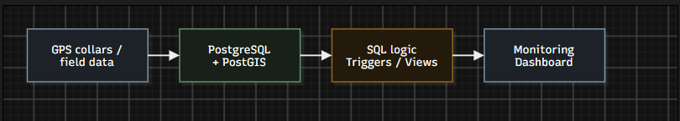
Figure 1. Proposed data flow based on the project presentation and SQL implementation.

The system is built on the high-level flow as Wildlife Data → PostgreSQL + PostGIS → SQL Queries→ Monitoring Dashboard.
In the relational layer, GPS points are checked against risk-zone polygons. A risk event can lead to a detected alert. A prediction record can lead to a predicted alert. Alerts can then be assigned to rangers.

4.4 Technologies
Layer | Technology / component | Role
Database | PostgreSQL | Stores relational conservation records.
Spatial extension | PostGIS | Geometry types, spatial functions and GiST indexes.
Database programming | SQL and PL/pgSQL | Queries, functions, triggers and views.
Dashboard | React + Vite frontend; Node.js + Express API in associated dashboard project | Presents information and communicates with backend endpoints; verify live DB endpoint mapping in repository.

5. ER DIAGRAM AND RELATIONAL SCHEMA

Species and Reserve provide reference data. Animal is the central entity for an individual tracked animal. GPS_Tracking stores time-based observations. Risk_Zone and Habitat_Zone describe geographic areas within reserves. Animal_Risk_Event records detected risk situations. Prediction stores predicted risk output. Alert and Alert_Assignment support the response process.
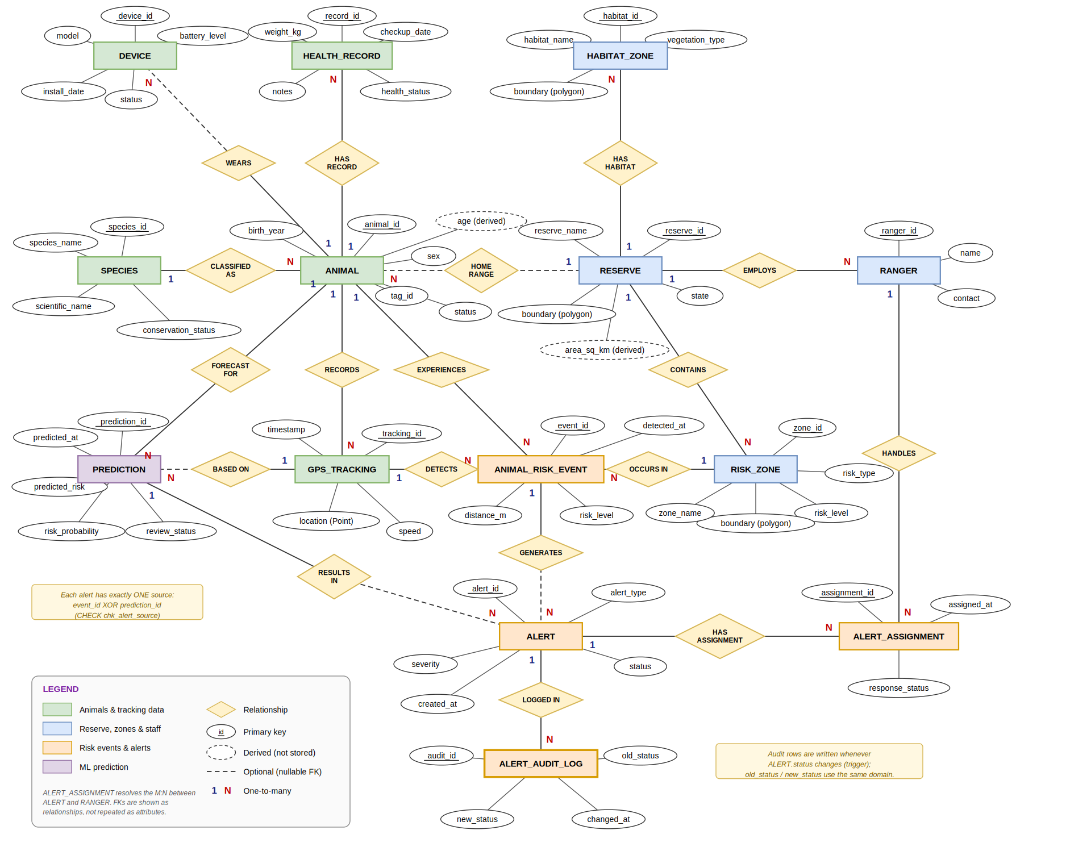

Figure 2. Logical ER diagram derived from the supplied SQL table definitions.

5.1 Main entities and attributes
Relation | Primary key | Important attributes / foreign keys
Species | species_id | species_name, scientific_name, conservation_status
Reserve | reserve_id | reserve_name, state, boundary (Polygon, SRID 4326)
Animal | animal_id | species_id FK, home_reserve_id FK nullable, tag_id UNIQUE, sex, birth_year, status
GPS_Tracking | tracking_id | animal_id FK, timestamp, location (Point, SRID 4326), speed
Risk_Zone | zone_id | reserve_id FK, zone_name, risk_type, risk_level, boundary (Polygon, SRID 4326)
Habitat_Zone | habitat_id | reserve_id FK, habitat_name, vegetation_type, boundary (Polygon, SRID 4326)
Device | device_id | animal_id FK nullable, model, battery_level, install_date, status
Health_Record | record_id | animal_id FK, checkup_date, weight_kg, health_status, notes
Animal_Risk_Event | event_id | animal_id FK, zone_id FK, tracking_id FK, detected_at, distance_m, risk_level
Prediction | prediction_id | animal_id FK, tracking_id FK nullable, predicted_at, predicted_risk, risk_probability, review_status
Alert | alert_id | event_id FK or prediction_id FK, alert_type, severity, created_at, status
Ranger | ranger_id | reserve_id FK, name, contact
Alert_Assignment | assignment_id | alert_id FK, ranger_id FK, assigned_at, response_status
Alert_Audit_Log | audit_id | alert_id FK, old_status, new_status, changed_at

5.2 Relationship summary
Relationship | Cardinality / rule
Species – Animal | One species can classify many animals; each animal references one species.
Reserve – Animal | A reserve can be home reserve for many animals; home_reserve_id is optional.
Animal – GPS_Tracking | One animal can have many GPS records; each record belongs to one animal.
Animal – Device | A device may be assigned to an animal; assignment is optional.
Animal – Health_Record | One animal can have many health records.
Reserve – Risk_Zone / Habitat_Zone | One reserve can contain multiple risk zones and habitat zones.
Reserve – Ranger | One reserve can employ multiple rangers.
Animal / Risk_Zone / GPS_Tracking – Animal_Risk_Event | Each event links an animal, a risk zone and the GPS observation used for detection.
Animal_Risk_Event / Prediction – Alert | An alert has exactly one source: a detected event or a prediction.
Alert / Ranger – Alert_Assignment | Alerts can be assigned to rangers; a ranger can handle multiple assignments.

5.3 Relational schema notation
SPECIES(species_id PK, species_name, scientific_name, conservation_status)
RESERVE(reserve_id PK, reserve_name, state, boundary)
ANIMAL(animal_id PK, species_id FK, home_reserve_id FK NULL, tag_id UNIQUE, sex, birth_year, status)
GPS_TRACKING(tracking_id PK, animal_id FK, timestamp, location, speed)
RISK_ZONE(zone_id PK, reserve_id FK, zone_name, risk_type, risk_level, boundary)
HABITAT_ZONE(habitat_id PK, reserve_id FK, habitat_name, vegetation_type, boundary)
DEVICE(device_id PK, animal_id FK NULL, model, battery_level, install_date, status)
HEALTH_RECORD(record_id PK, animal_id FK, checkup_date, weight_kg, health_status, notes)
ANIMAL_RISK_EVENT(event_id PK, animal_id FK, zone_id FK, tracking_id FK, detected_at, distance_m, risk_level)
PREDICTION(prediction_id PK, animal_id FK, tracking_id FK NULL, predicted_at, predicted_risk, risk_probability, review_status)
ALERT(alert_id PK, event_id FK NULL, prediction_id FK NULL, alert_type, severity, created_at, status)
RANGER(ranger_id PK, reserve_id FK, name, contact)
ALERT_ASSIGNMENT(assignment_id PK, alert_id FK, ranger_id FK, assigned_at, response_status)
ALERT_AUDIT_LOG(audit_id PK, alert_id FK, old_status, new_status, changed_at)

6. KEYS, CONSTRAINTS AND FUNCTIONAL DEPENDENCIES

6.1 Keys
Each principal entity uses a surrogate primary key, generally generated with SERIAL or BIGSERIAL. Animal.tag_id is declared UNIQUE and NOT NULL, making it an alternate unique identifier. Foreign keys connect dependent records to parent entities, such as Animal.species_id → Species.species_id and GPS_Tracking.animal_id → Animal.animal_id. Alert_Assignment also enforces UNIQUE(alert_id, ranger_id, assigned_at).

6.2 Constraints
Constraint | Where applied | Purpose
PRIMARY KEY | All main entity tables | Uniquely identifies each row.
FOREIGN KEY | Animal, tracking, zones, events, predictions, alerts, rangers, assignments | Maintains referential integrity.
NOT NULL | Required identifiers, names, categories, timestamps and geometries | Prevents missing mandatory values.
UNIQUE | Animal.tag_id; assignment alert/ranger/time combination | Prevents duplicate identifiers and assignment combinations.
CHECK | Sex and animal status | Restricts values to declared categories.
CHECK | Risk type and risk level | Restricts supported risk categories.
CHECK | Prediction risk/probability/review status | Probability must be between 0 and 1; values restricted to valid labels.
CHECK | Alert source and alert type | Requires exactly one source and matches it to detected/predicted type.
CHECK | Device battery and status | Battery range 0–100; valid device states only.
CHECK | Health status and vegetation type | Restricts health and habitat categories.
DEFAULT | Timestamps, statuses and review state | Supplies initial values when omitted.

6.3 Functional dependencies
The following dependencies follow from the primary keys and unique constraints declared in the SQL schema. Each key determines the remaining attributes in its relation:
- species_id → species_name, scientific_name, conservation_status
- reserve_id → reserve_name, state, boundary
- animal_id → species_id, home_reserve_id, tag_id, sex, birth_year, status; tag_id → animal_id
- tracking_id → animal_id, timestamp, location, speed
- zone_id → reserve_id, zone_name, risk_type, risk_level, boundary
- habitat_id → reserve_id, habitat_name, vegetation_type, boundary
- device_id → animal_id, model, battery_level, install_date, status
- record_id → animal_id, checkup_date, weight_kg, health_status, notes
- event_id → animal_id, zone_id, tracking_id, detected_at, distance_m, risk_level
- prediction_id → animal_id, tracking_id, predicted_at, predicted_risk, risk_probability, review_status
- alert_id → event_id, prediction_id, alert_type, severity, created_at, status
- ranger_id → reserve_id, name, contact
- assignment_id → alert_id, ranger_id, assigned_at, response_status
For Alert_Assignment, the composite uniqueness rule also gives (alert_id, ranger_id, assigned_at) → assignment_id and the remaining assignment attributes. These dependencies are based on the actual declared keys; no additional business rules are assumed.

7. NORMALIZATION

7.1 First Normal Form (1NF)
Attributes are atomic and each row represents one entity occurrence. GPS observations, health checks and risk events are stored as separate records rather than repeating groups in Animal. An animal with multiple location observations therefore has multiple GPS_Tracking rows.

7.2 Second Normal Form (2NF)
The main relations use single-column surrogate primary keys, so there are no partial dependencies on part of a composite primary key in those relations. Animal details are stored in Animal, species details in Species and reserve details in Reserve.

7.3 Third Normal Form (3NF)
Information dependent on different entities is separated. Species attributes are stored in Species, reserve attributes in Reserve, ranger details in Ranger and risk-zone attributes in Risk_Zone. Dependent tables reference these entities through foreign keys. This reduces update anomalies and unnecessary transitive dependencies.

8. IMPLEMENTATION DETAILS

8.1 DBMS and spatial extension
The database is implemented in PostgreSQL and uses the PostGIS extension. The SQL script enables PostGIS and declares GPS_Tracking.location as geometry(Point, 4326). Reserve.boundary, Risk_Zone.boundary and Habitat_Zone.boundary are geometry(Polygon, 4326). This supports spatial containment and distance-based analysis.

8.2 Sample data
The SQL file contains seed INSERT statements for the principal entities. Sample records cover Indian wildlife species and protected areas, animal records, GPS observations, risk zones, devices, ranger records, habitat zones and health records. This data supports joins, spatial queries and reporting without requiring live collar data.

8.3 Indexing strategy
GiST indexes are created on reserve, risk-zone, GPS-location and habitat boundaries/locations. Additional indexes support animal/time tracking history, risk events by animal, alert status, ranger assignment workload, devices by animal, health records by animal/date and foreign-key lookups. These indexes are intended to improve spatial operations and common relational access patterns.

8.4 Database automation
The SQL file contains PL/pgSQL functions and triggers for GPS validation, risk checking, event creation, alert generation, ranger assignment, status synchronization, alert auditing, prediction review, device checks, health synchronization and validation of animal and zone data. Risk-level conversion and severity mapping functions are also defined.

8.5 Reporting views
Dashboard-oriented views include v_open_alerts, v_animal_latest_position, v_reserve_risk_summary, v_ranger_workload, v_species_dashboard, v_device_health, v_animal_health_latest, v_high_risk_animals, v_prediction_review_queue and v_zone_hotspots. These provide reusable query layers for monitoring and reporting.

8.6 Application and database connectivity
The database is intended to be accessed through an application backend, which exposes information to the monitoring dashboard. The associated dashboard project uses React with Vite, JavaScript and CSS for the frontend and Node.js with Express for the API layer. Database credentials should be supplied through environment variables rather than embedded in source code.

8.7 SQL execution safety
The supplied SQL script begins by dropping the PostGIS extension and recreating the public schema. This is destructive and can remove existing objects and data. It should only be run in a disposable development database or after a verified backup. It must not be executed against a shared or production database without removing the reset statements and reviewing the migration plan.

9. IMPORTANT SQL OPERATIONS AND IMPLEMENTED FEATURES

9.1 Join: animal and species
SELECT a.animal_id, s.species_name
FROM Animal a
JOIN Species s ON a.species_id = s.species_id;
Combines animal records with the corresponding species name using the foreign-key relationship.

9.2 Aggregation: risk events by level
SELECT risk_level, COUNT(*)
FROM Animal_Risk_Event
GROUP BY risk_level;
Groups risk events by severity and counts the records in each group.

9.3 Subquery: animals belonging to endangered species
SELECT animal_id, tag_id
FROM Animal
WHERE species_id IN (
SELECT species_id FROM Species
WHERE conservation_status = 'Endangered'
);
The inner query identifies endangered species; the outer query retrieves the animals classified under those species.

9.4 Spatial query: GPS points within risk zones
SELECT g.tracking_id, rz.zone_name
FROM GPS_Tracking g
JOIN Risk_Zone rz
ON ST_Within(g.location, rz.boundary);
ST_Within tests whether a GPS point lies inside a risk-zone polygon and associates the tracking record with that zone.

9.5 Event-to-alert workflow
The SQL implementation defines a GPS validation trigger and a risk-check trigger. When configured conditions are met, an Animal_Risk_Event can be inserted. A further trigger creates a detected alert from an event. Prediction records can similarly produce predicted alerts. Assignment logic creates an Alert_Assignment record for a ranger, while other triggers synchronize response status and maintain an audit history.

9.6 Additional operational queries
SELECT * FROM v_animal_latest_position;
SELECT * FROM v_open_alerts;
SELECT * FROM v_ranger_workload;
SELECT * FROM fn_low_battery_devices(20);
SELECT * FROM fn_animals_outside_reserve();
The view and function names above are present in the SQL script. Function signatures and returned columns should be checked in the database client when reproducing results.

9.7 Implemented DBMS features
Feature | Evidence in project SQL / presentation
DDL | CREATE TABLE statements for core entities and audit log.
DML | Seed INSERT statements; triggers/functions also insert and update operational records.
Joins and subqueries | Animal–Species join and endangered-species subquery in presentation.
Aggregation | Risk-event counts grouped by risk level.
Spatial SQL | ST_Within and geometry(Point/Polygon, 4326).
Constraints | PK, FK, UNIQUE, NOT NULL, CHECK and DEFAULT declarations.
Indexes | GiST spatial indexes and B-tree indexes for query patterns and foreign keys.
Functions and triggers | Risk validation, alert creation, ranger assignment, auditing and summaries.
Views | Reusable summaries for alerts, animals, reserves, rangers, devices and zones.

10. TESTING, RESULTS AND DISCUSSION

Test | Procedure | Expected result / evidence
T01 – DDL | Run reviewed DDL in a clean test database. | Tables and PostGIS geometry columns are created; capture table list.
T02 – FK integrity | Insert an Animal with a non-existent species_id. | Foreign-key constraint rejects the row.
T03 – Domain validation | Insert an invalid animal status or risk_level. | CHECK constraint rejects the value.
T04 – Unique tag | Insert two animals with the same tag_id. | UNIQUE constraint prevents duplicate tag.
T05 – Spatial containment | Run ST_Within for known GPS points and risk polygons. | Returns tracking points contained by risk-zone polygons.
T06 – Risk detection | Insert a GPS record meeting configured risk-check conditions. | Risk-event trigger creates an event; verify Animal_Risk_Event.
T07 – Alert generation | Create an event and a prediction record. | Alert triggers create detected/predicted alerts with correct source.
T08 – Assignment | Create an alert where eligible ranger data exists. | Alert_Assignment row links alert and ranger.
T09 – Audit | Change an alert status. | Audit log records old and new status.
T10 – Views | Query dashboard reporting views. | Views return alert, latest-position, reserve-risk and ranger summaries.

10.1 Results and discussion
The schema connects animal identity, species classification, reserve membership, GPS history, health records and device information. Spatial data uses suitable geometry types, allowing geographic conditions to be expressed directly in SQL. The risk-event and alert entities separate threat detection from the response process.
Views and functions provide reusable information for a dashboard. Indexes are defined for spatial lookups and frequently used relational filters. The alert source constraint is important: an alert must refer to either an event or a prediction, not both, and alert_type must agree with the populated source.

10.2 Screenshots
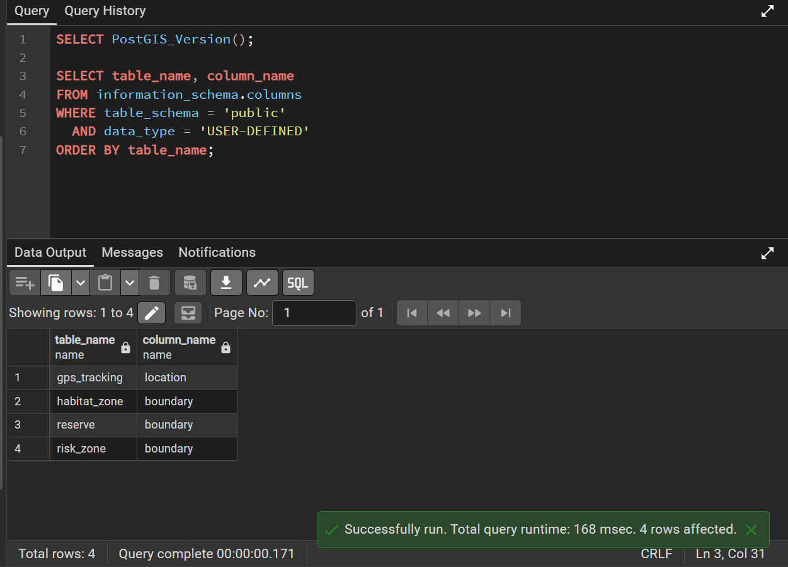

Figure 10.2.1 Displaying the PostGIS tables
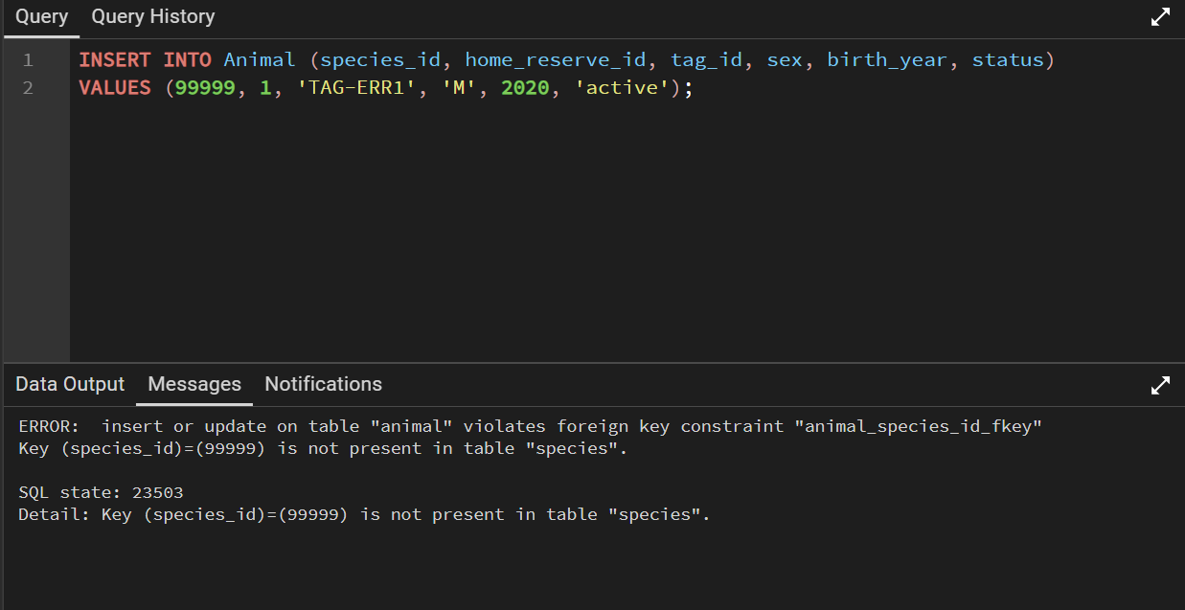

Figure 10.2.2: Invalid insertion for foreign key constraint
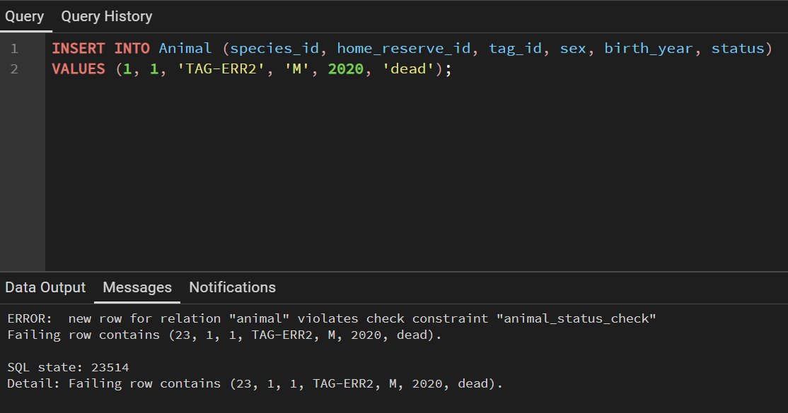Figure 10.2.3: Invalid Insertion – check constraint
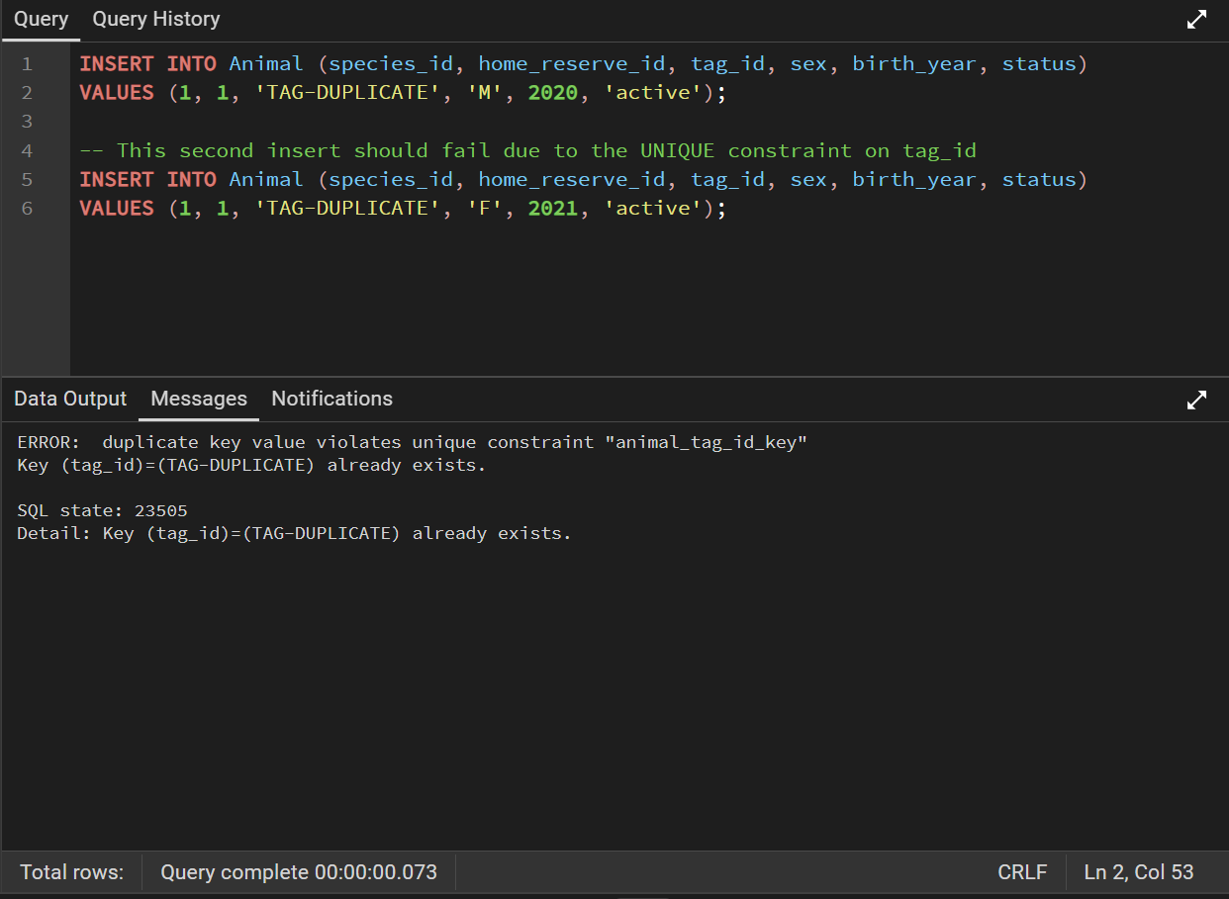 Figure 10.2.4: Invalid Insertion – primary key constraint
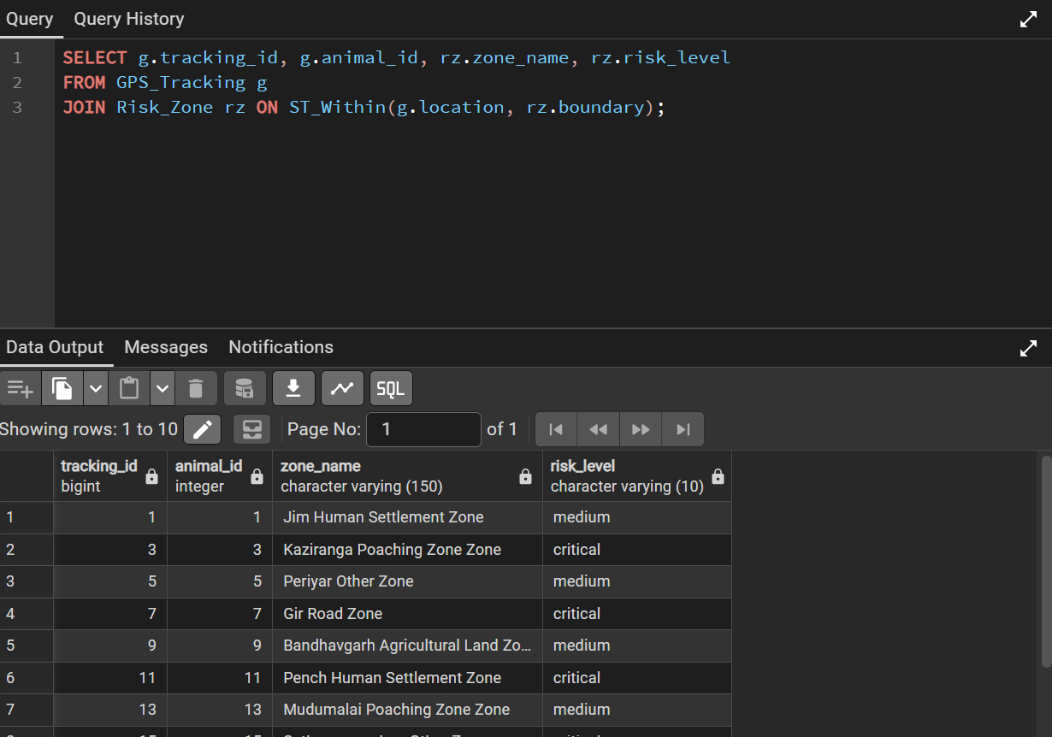Figure 10.2.5: Checking the spatial containment of the animals
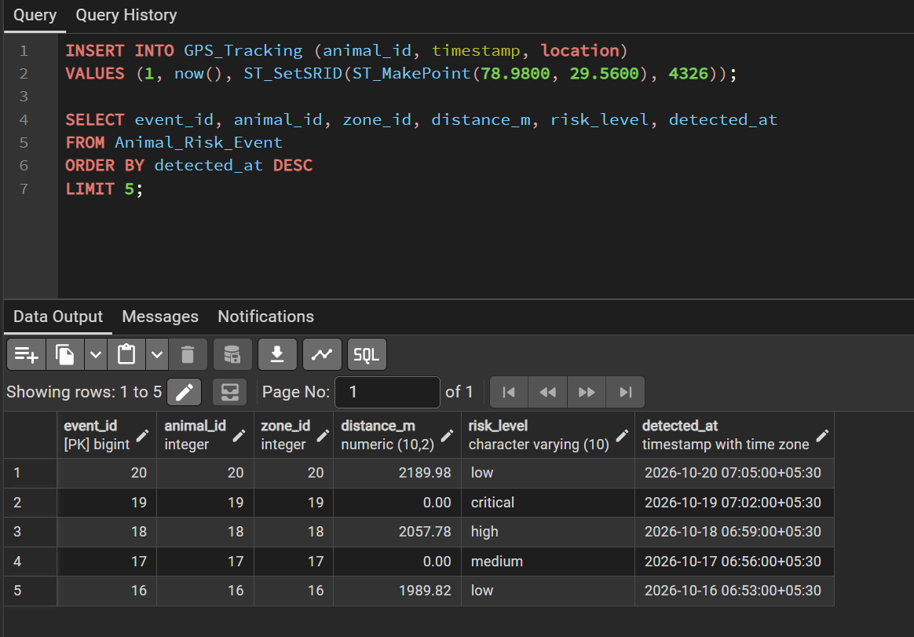Figure 10.2.6: Cascading insert in Animal_Risk_Event.
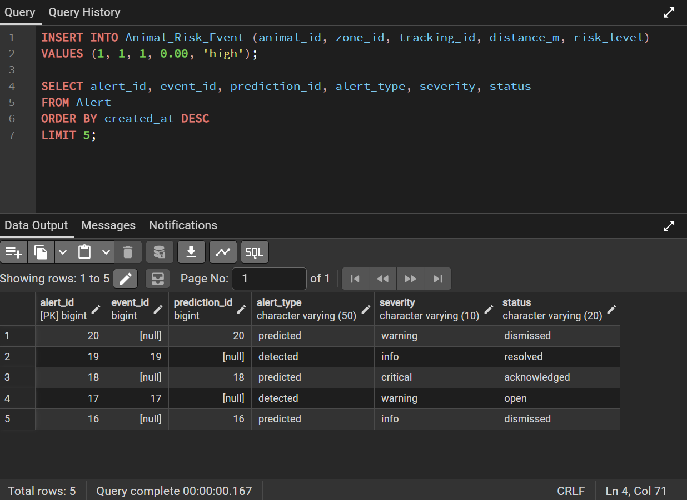Figure 10.2.7: Cascading insert in Alert.
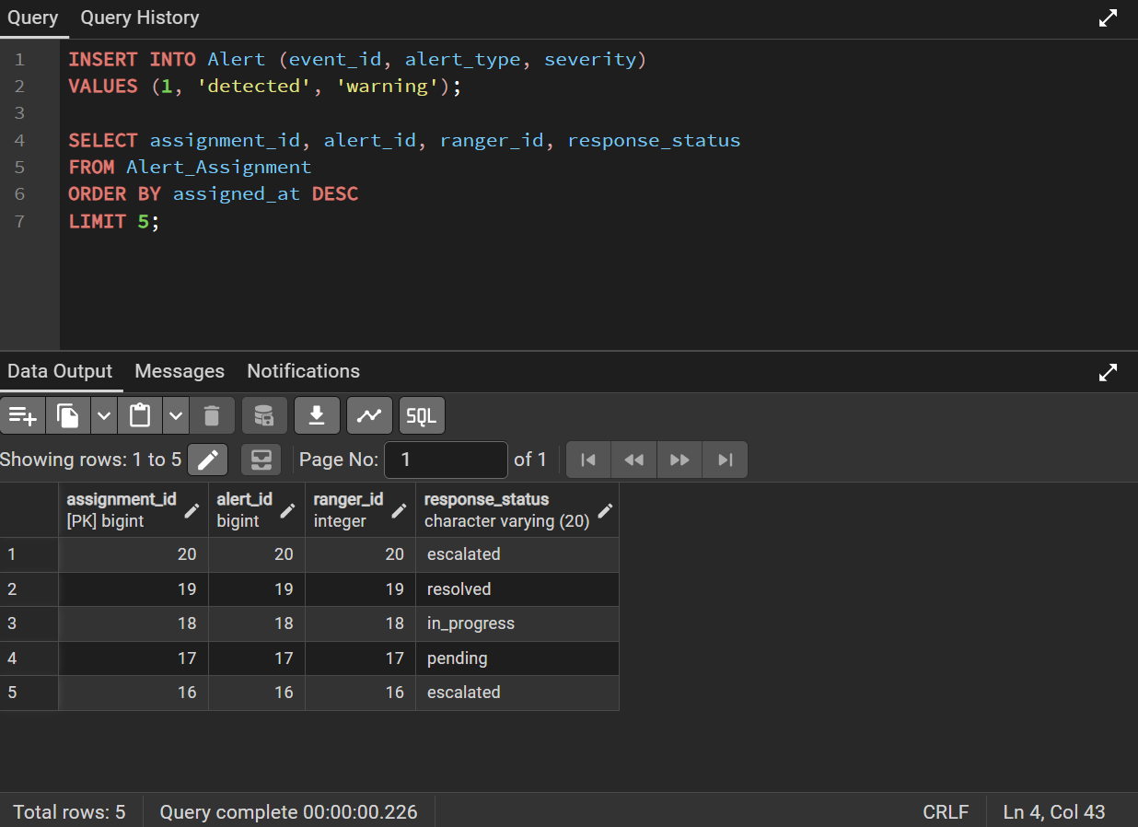

Figure 10.2.8: Cascading insert in Alert_Assignment.
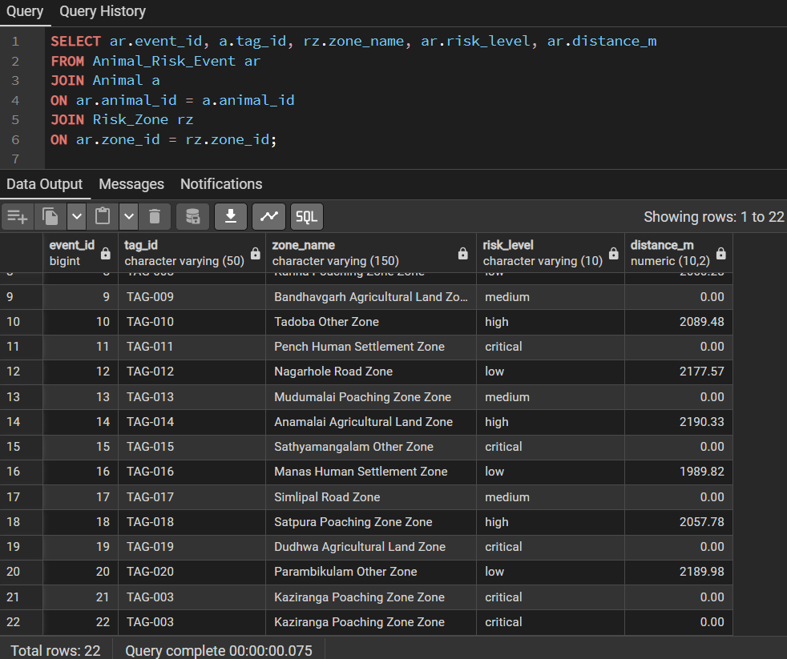 Figure 10.2.9: Retrieval of animal risk events with associated risk zones and distances.

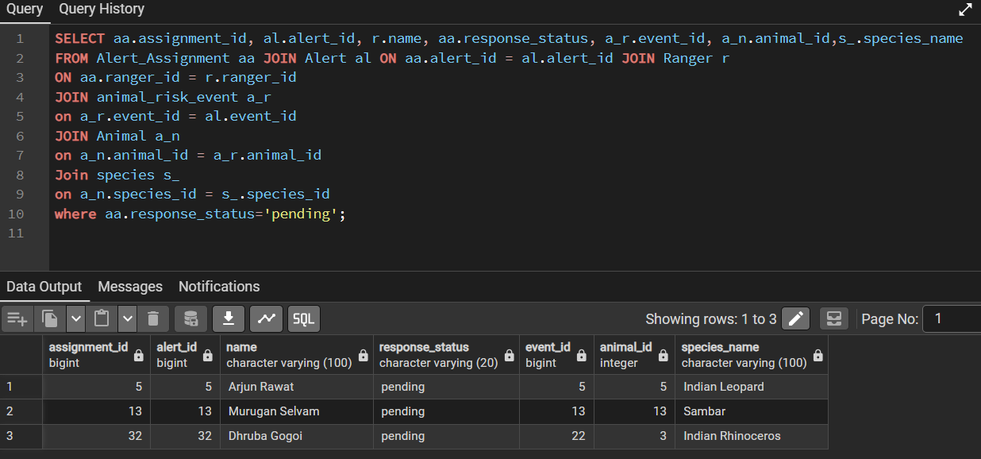 Figure 10.2.10: Retrieval of pending alert assignments with ranger and animal details.
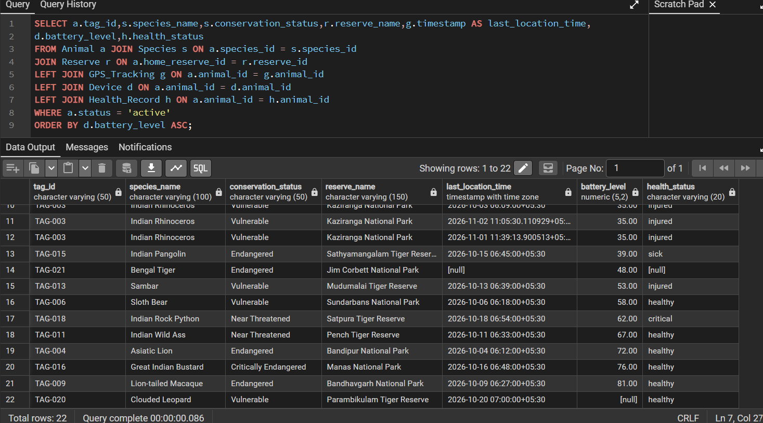 Figure 10.2.11: Comprehensive animal monitoring report using multiple table joins.
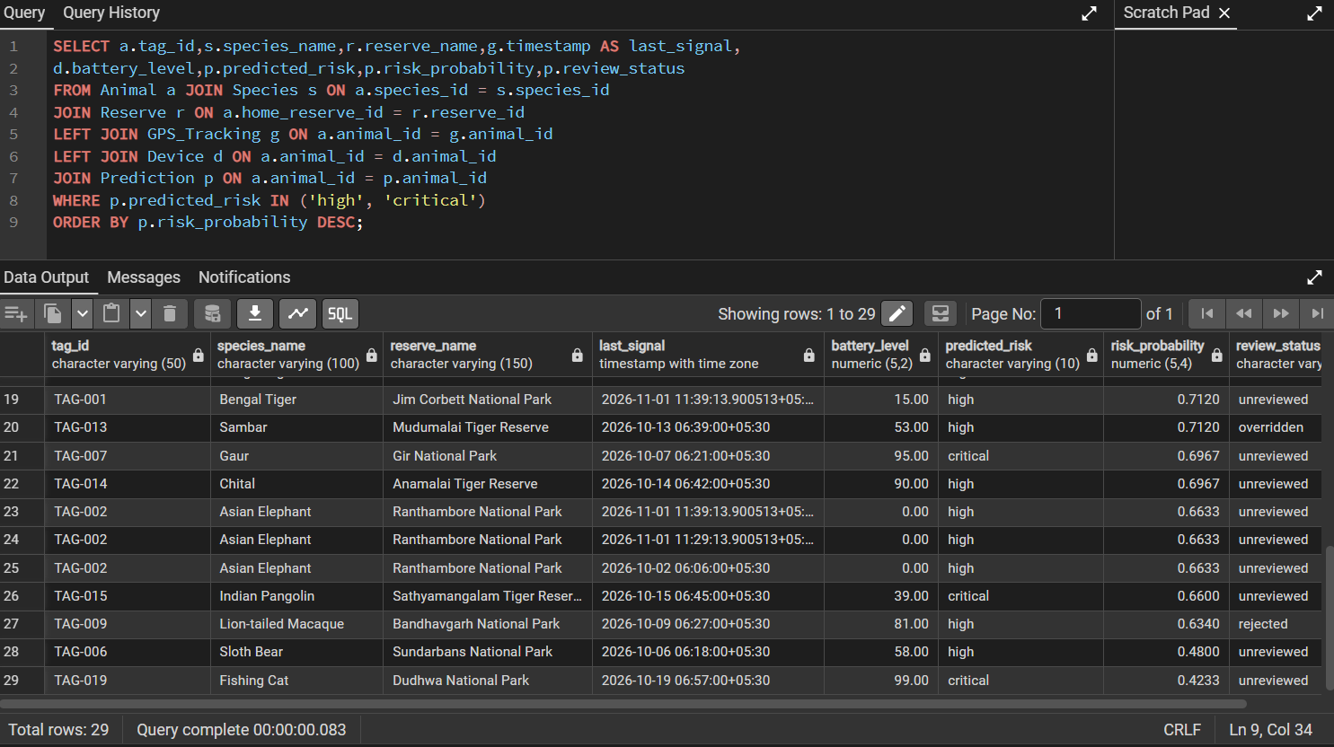 Figure 10.2.12: Retrieval of high-risk animal predictions with reserve and tracking details.

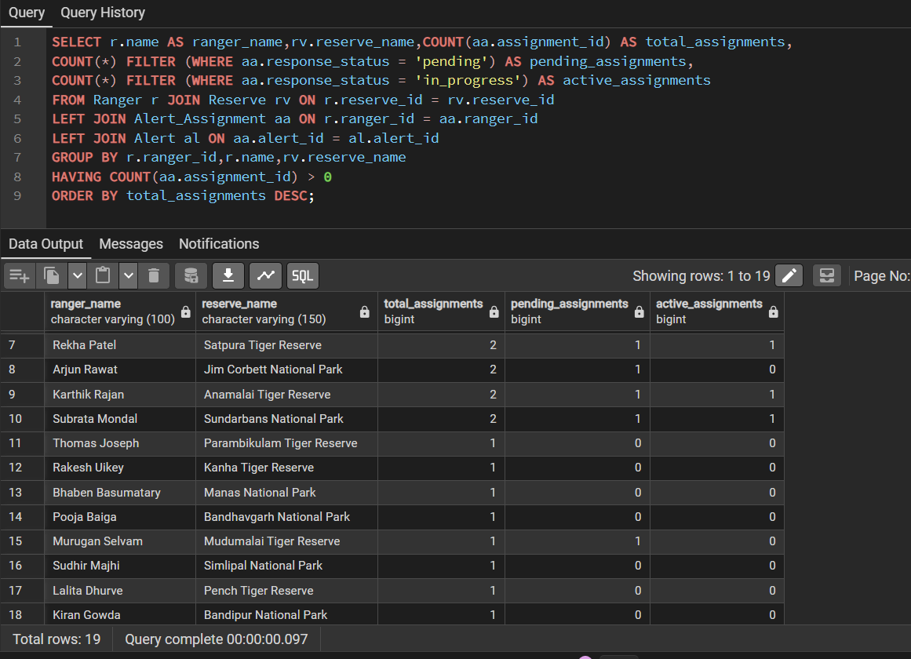 Figure 10.2.13: Ranger workload analysis with assignment status.

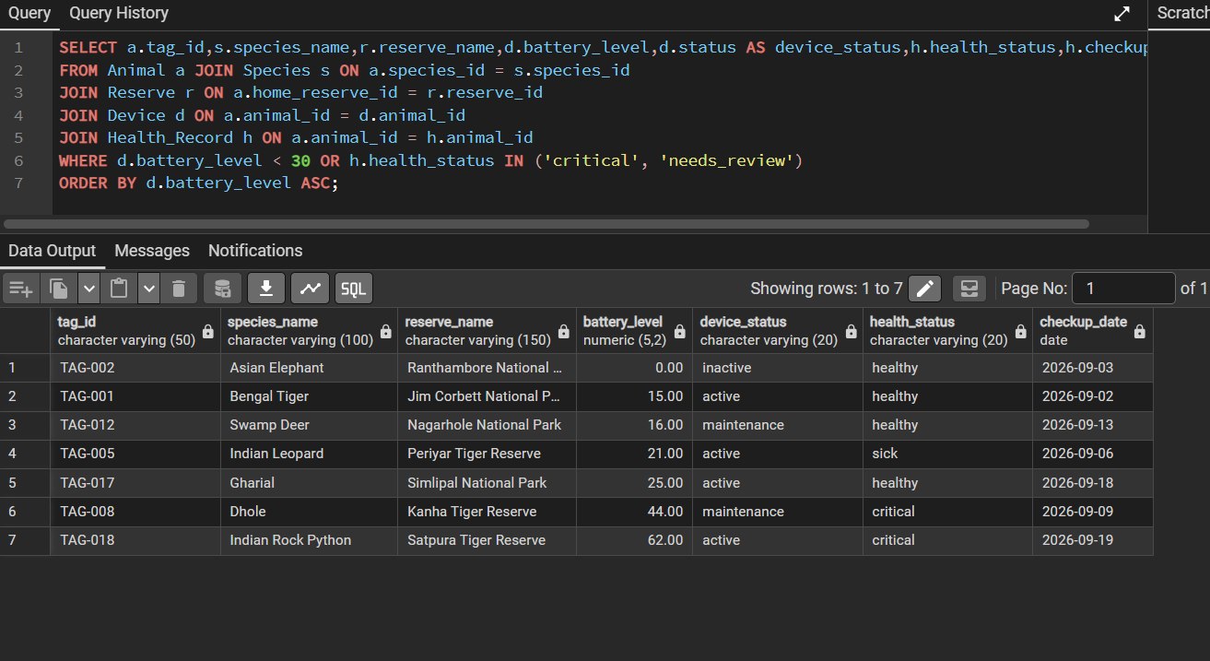 Figure 10.2.14: Retrieval of animals with low battery levels and health issues.

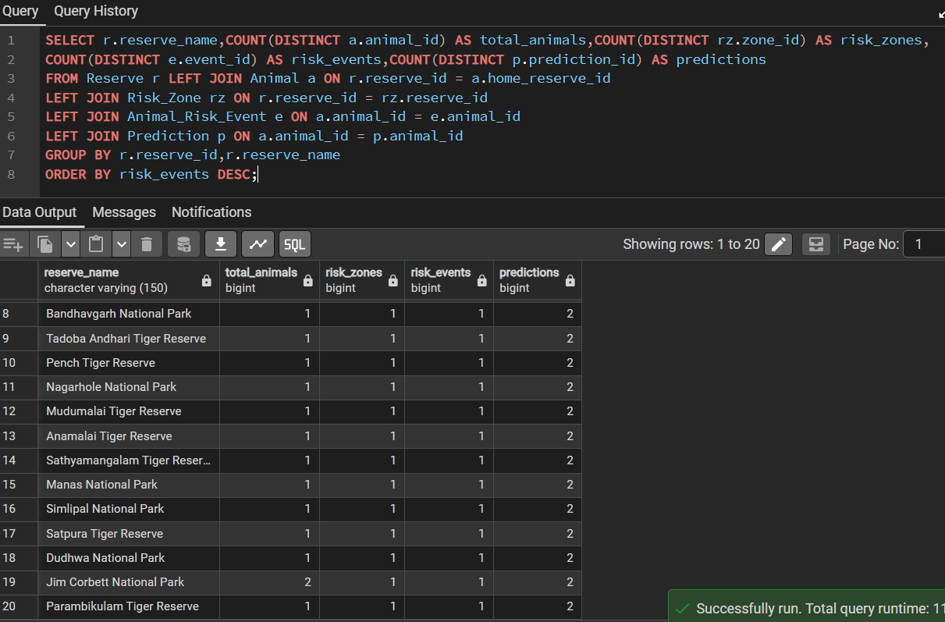 Figure 10.2.15: Reserve-wise wildlife risk and prediction analysis.

11. LIMITATIONS AND FUTURE ENHANCEMENTS

11.1 Current limitations
- The database stores predicted risk and probability but does not prove model accuracy.
- Risk detection depends on GPS observation quality and the accuracy of reserve/risk-zone polygons.
- No measured query latency, load-test results or formal performance comparison were included in the supplied materials.
- Live dashboard-to-database connectivity and end-to-end alert behaviour must be validated in the deployed environment.

11.2 Future enhancements
- Integrate a documented AI model that consumes movement features and stores versioned predictions with model metadata.
- Complete and document Neo4j integration if graph-based analysis is required.
- Add authentication and role-based access for administrators, rangers and researchers.
- Add data-quality checks for GPS outliers, missing timestamps, duplicate messages and invalid geometries.
- Add historical movement playback, risk heat maps and configurable notifications.
- Measure performance with representative data volumes and tune indexes using EXPLAIN ANALYZE.
- Add automated backups, migration scripts and a non-destructive deployment process.

12. CONCLUSION
WildGuard presents a database-oriented approach to wildlife monitoring by connecting animal records, species information, GPS observations, reserves, habitats, risk zones, health records, devices, predictions and ranger response information. PostgreSQL provides the relational foundation, while PostGIS enables spatial representation and geographic queries. The schema uses primary keys, foreign keys, domain constraints, uniqueness rules and normalization to maintain data consistency.
The project extends beyond basic record storage through spatial indexes, reusable functions, triggers and dashboard-oriented views. Its risk workflow links location observations to risk events, alerts and ranger assignments. The presentation and SQL script together demonstrate the central DBMS design and implementation concepts required for the assignment. Further work should validate live application integration, document the AI model and complete any Neo4j integration included in the final deployment.

REFERENCES
[1] EarthRanger, “Protecting Wildlife With Real-Time Data.” [Online]. Available: https://www.earthranger.com/. Accessed:
[2] Movebank, “About Movebank,” Max Planck Institute of Animal Behavior. [Online]. Available: https://www.movebank.org/cms/movebank-content/about-movebank. Accessed: Nov. 1, 2026.
[3] Food and Agriculture Organization of the United Nations, “Spatial Monitoring and Reporting Tool (SMART),” Sustainable Forest Management Toolbox. [Online]. Available: https://www.fao.org/sustainable-forest-management/toolbox/tools/tool-detail/en/c/1255907/. Accessed: Nov. 1, 2026.
[4] PostgreSQL Global Development Group, “PostgreSQL Documentation.” [Online]. Available: https://www.postgresql.org/docs/. Accessed: Nov. 1, 2026.
[5] PostGIS Project Steering Committee, “PostGIS Documentation.” [Online]. Available: https://postgis.net/documentation/. Accessed: Nov. 1, 2026.

